On-Call Process

(CES, SAC)

Table of Contents
Links 3
PagerDuty Setup 3
Jobs and Job Types 4
CES Process 5
Special Job Instructions 7
Create GWX Ticket 8
Control-M Ticket 8
Clear Alert 9

Links

CES and SAC Production Schedule:
https://lmsp4-intl.external.lmco.com/sites/CES/Shared%20Documents/MS2%20CFS%20Production%20Schedule/MST%20CES%20Production%20Schedule%20(ctmRMSd2-ctmPE3d1).xlsx

Control-M:
https://controlm.us.lmco.com:8446/ControlM/

Gateway Ticket:
https://servicecentral.external.lmco.com/service_central_portal?id=sc_cat_item&sys_id=02dc9e17dbfc88d028b43efd7c96192b&qeid=a551fe5a1bfd20d0162ba866bc4bcb57

PagerDuty Setup

- Go to LMPeople https://lmpeople.lmco.com/LMPeople_Home.aspx
- Go under Contact Information in the Personal Information section
- Add your contact information which is your personal phone number under the Business Cell/Mobile that will be called/texted by the Paging team
- If you do not feel comfortable adding your personal number in this section and would like Company Phone please reach out to your manager to request one.

Jobs and Job Types

For CES/TEMPO/Hyperion Jobs they all start with the following:
- E20
- E22
- E24
- E25
- E26
- E27
- E28
- E33
- E64
- E88
- E97
- E98
- E99
For SAC Jobs they all start with the following:
- E34
- E61
- E91

The Different job types are as follows (seen in column F of the excel):
- AFT/MFT (File Transfers)
- Filewatchers (Monitor Files in the system)
- Data Services (Run scripts in Data Services)
- Resource (Limit multiple runs of the same job)
- SAP Program (Runs a process in SAP)
- Sleep (Jobs that delay a job stream to ensure full processing is complete)
- Unix Scripts (Run unix commands)
- Windows Bat (Run windows commands)

CES Process

- Receive the call from PagerDuty
  - Choose the acknowledge option in the response and you will be assigned a ticket with the details of the failure
- Log into Control-M
  - Place the job on hold 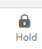
  - Go to the alerts window and look for the job in the list, write in the comments window that you are looking into the failure and click save
  - Mark the alert as Reviewed 
- Open the CES Production Schedule and look for the job in the spreadsheet
  - Verify the Job type to gather more information
    - If the job is an SAP Program
      - Log into SAP PM1
      - Enter transaction SM37 in the search bar
      - Search for the job name, change the username to (*), add the current date and then click execute
      - Once job comes up check the log by selecting the canceled run and then click on the Job Log button
      - Gather the information on the failure and take note of what the issue is.
      - Check if column AJ has any notes, if something exists check the Recovery Instructions tab in how to handle the jobs
        - Contact the second/third line of contact (columns AH/AI) to give them the failure and request how to address it. Should you not receive a response then reach out to the Module lead (column AO)
          - The Module Lead appears in the Module Contacts tab
        - The Functional team will inform how to address the failure.
    - If the job is an AFT
      - Check the type of failure, ex. Connection, Missing File
      - If the failure appears to be a connection problem, try to rerun the job to see if it works.
        - If the rerun fails, reach out the Second Line of Contact
      - If the failure is a missing file reach out to the Third Line of Contact to find out what happened to the file.
    - If the job is Unix Script/Sleep/Windows Bat/Resource, reach out to the Second Line of Contact to investigate the problem
    - If the job is a Filewatcher
      - Check column T to see the file path
      - Log into SAP
      - Enter transaction AL11 in the search bar
      - Dig down into the file path from column T to verify if the file is there
      - If the file exists rerun the job
      - If the file is missing
        - Reach out to the First/Second/Third line of contacts to find information on where the missing file is and when it will be sent
          - If the file comes from the Gateway (filepath includes gwx) then a ticket must be created for them to send the file over (link in page 3) (Steps to create the ticket page 7).
        - Once the file received rerun the job.
        - If the file will not be available on the same day, contact the Module Lead to inform them. They will advise on what to do.

Special Job Instructions
- Latesub Alert
  - When a job doesn’t execute at a specific time or is running too long a Page will go out.
  - Log in to Control-M
  - Open the Alerts window to see which job triggered the page which will display which job is being delayed
  - Mark the alert as read and send an email to the Job-Request DL (job-request.dl-ces@exch.ems.lmco.com) with the expected start time / end time of the job.
- Job E64PEG1S1D
  - Check the column AJ which has information on a specific error message
  - If the failure has the plant locked error message please contact Jose Rodriguez Jinel, Duane Setzer or Jesus Calo Castro to address the failure.
- Job Flows that Include Resource Jobs
  - If the failed job will be forced completed the successors need to be deleted except the Resource Job which needs to be run so that the subsequent Job stream can run
- Job E649194S1C
  - You will be paged if the job is running for longer than 10 minutes
  - Once you get online log into SAP PM1 and look for the job in t-code SM37
  - Mark the run that is executing and cancel the job so that it stops running
  - Log into Control-M and place the now failed job on hold
  - Check for an email from the FORECAM team once a fix has been implemented, restart the job and release it.
- Job E641389S3D
  - When job fails with error '/data/ces/PM1/LSMW/1389_PROJCRE.conv' File Has Not Been Accepted for Processing
    - Go to tcode WE21 in PM1
    - Go to the Ports folders and enter the File Folder
    - Click on the LSMW file
    - Unmark the Unicode Format checkbox and save 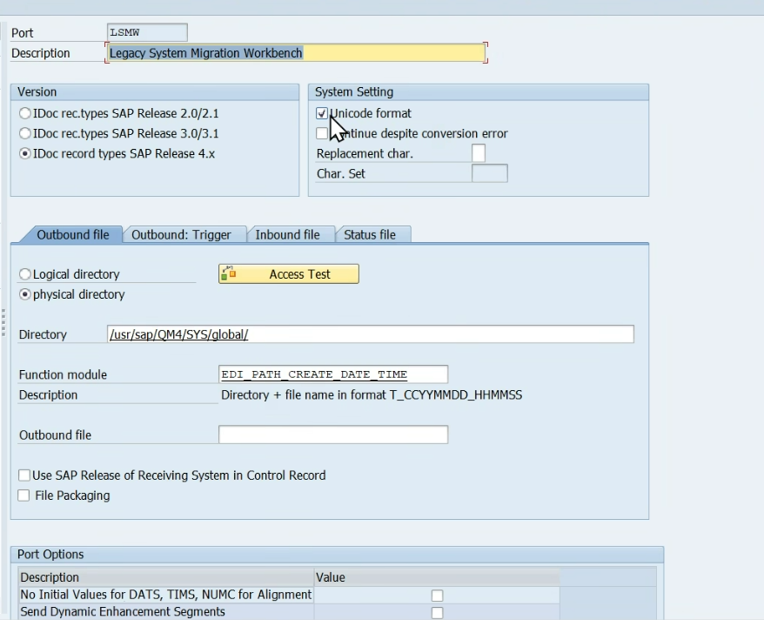
    - Go back to Control-M and rerun the failed job.
    - Once the job is completed successfully go back to tcode WE21 and mark the Unicode format checkbox again and save.

Create GWX Ticket
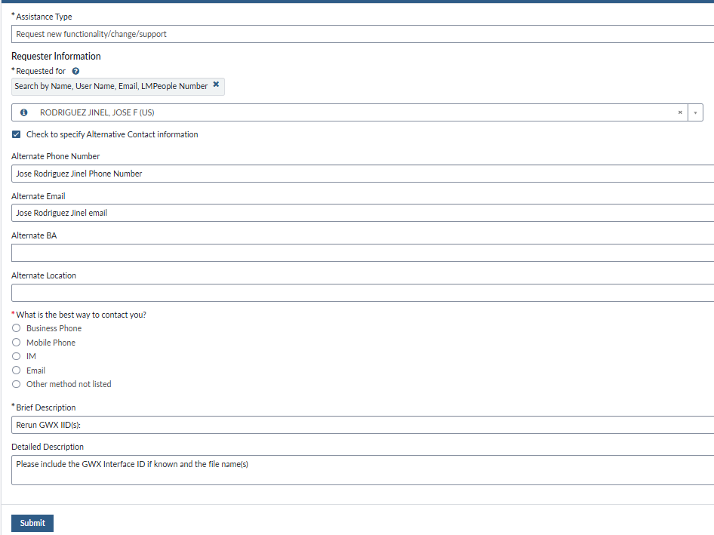
- The page auto populates with your information. Make sure to Jose Rodriguez Jinel as the Alternate Contact.
- In the brief description box please make sure to write down the GWXID that appears in column AE/AF/AH/AK of the Production Schedule. This same information needs to be entered in the Detailed Description box as well as the file name(s) that appears in the column T of the Production Schedule so that the GWX team can know what file(s) they need to resend.
- Once the ticket is submitted, you need to go into the ticket and raise urgency to 1-High so that Pager Duty can be triggered for the GWX team.

Control-M Ticket
- Once you acknowledge the page a ticket will be assigned to you
  - When acknowledge it will be marked as In Progress
- If you resolve the failure in Control-M go into the Resolution Information tab in the incident 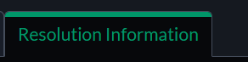
  - In the Resolution Code select Solved (Permanently) 
  - In the Resolution Notes write down what you did to fix the failure including whether you restarted or forced completed the job
  - In the Business Impact Assessment section add N/A
  - In the Business Impact choose 4 – No Impact 
  - Then mark the ticket as Resolved 
- If for some reason the job will not be addressed at that time of the failure, then mark the ticket Urgency as Medium and place the ticket On Hold.
  - Send an email to the team so that it can be addressed the following day.

Clear Alert

- If you restarted the job the alert gets cleared otherwise
  - Once the incident has been resolved, go into Control-M and head to the alerts section in the black toolbar at the top.
  - Search for the job that you addressed
  - In the comment section type out exactly what you did to address the failure
  - Highlight the line and click on the Closed button in the gray toolbar

